# District School Performance Analysis

## Overview of Project

Our company Data Analysts, Inc. (“DAI”) has worked with Maria, a school district superintendent, to deliver an analysis model the District can use to determine individual school performance and budget implementation.

## Scope of Project

DAI worked with Maria to provide the following:

1. Data points to be evaluated by breakouts (see below):
   1. Budget and per student budget
   2. Reading score
   3. Math score
   4. Percent passing (overall and by subjects: math and English)
2. Data Breakouts to be presented by:
   1. District Summary
   2. Per School Summary
   3. High Performing Schools
   4. Low Performing Schools
   5. Math Scores Presented by High School
   6. Reading Scores Presented by High School
   7. School Performance by Ranges of Spending Per Student
   8. School Performance by Ranges of School Size
   9. School Performance by School Type

After working with Maria, it was discovered the Thomas High School ninth grade student grades were corrupted. Therefore, the above analysis was refactored to exclude the Thomas High School ninth grade math and reading scores from the results. Thus, some of the focus of this study was to see how this change affected the outcomes once the grades were extracted.

## Analysis

###District Summary

District Summary – includes Thomas High School Ninth Graders:



District Summary – “excludes” Thomas High School Ninth Graders:

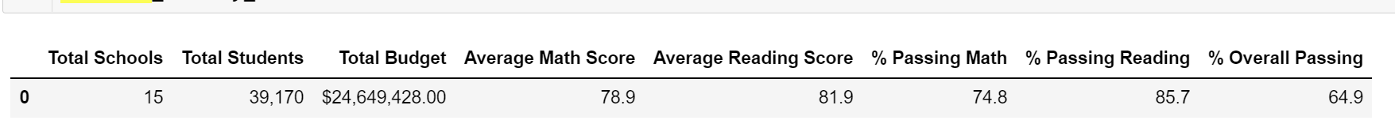

###Per School Summary

|  |  |  |  |  |  |  |  |  |  |
| --- | --- | --- | --- | --- | --- | --- | --- | --- | --- |
| **School** | **School**  **Type** | **Total**  **Students** | **Total School Budget** | **Per School Budget** | **Avg Math Score** | **Avg Reading Score** | **% Pass Math** | **% Pass Reading** | **% Overall Pass** |
| THS with 9th Graders | District | 1,635 | 1,043,130 | 638 | 83.4 | 83.9 | 66.9 | 69.7 | 65.1 |
| THS excl. 9th Graders | District | 1635 | 1043130 | 638 | 83.4 | 83.9 | 93.2 | 97.0 | 90.6 |

Per School Summary Report (excluding Thomas High School 9th graders):

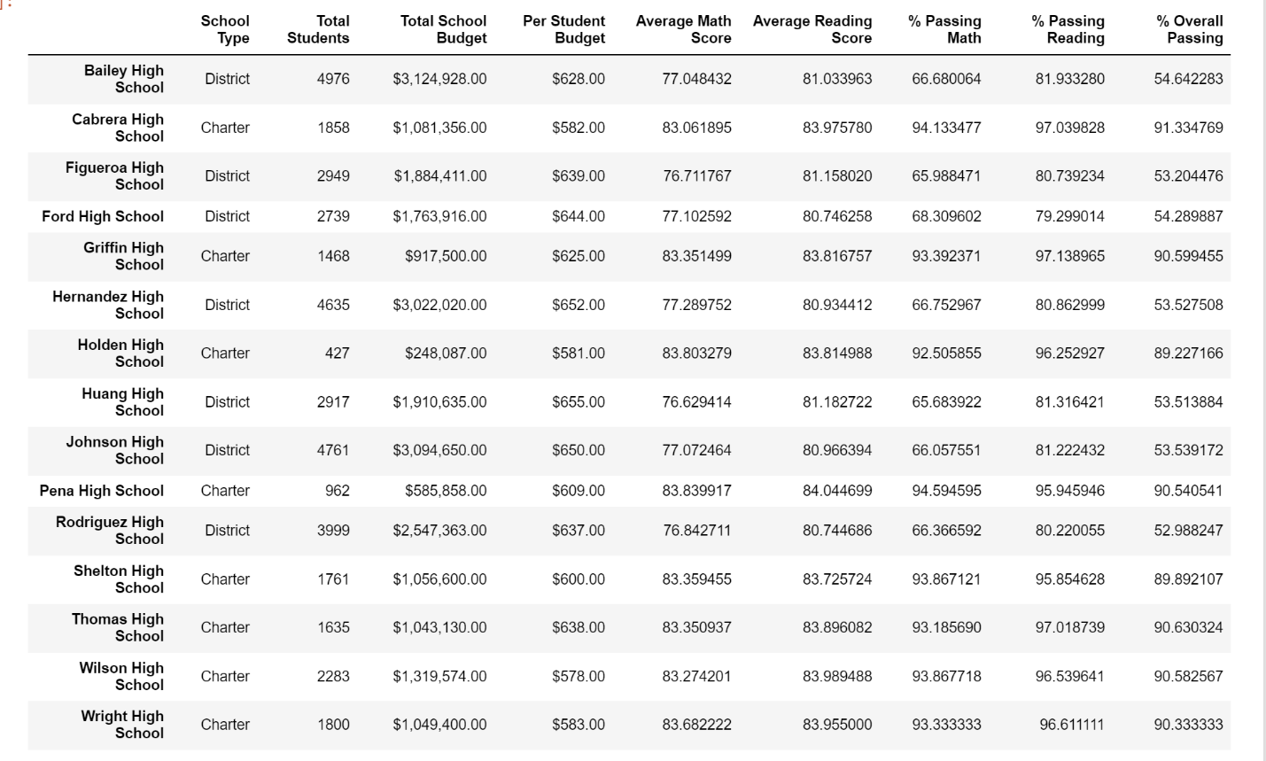

### Reading Scores Presented by High School

### School Performance by Ranges of Spending Per Student

### School Performance by Ranges of School Size

### School Performance by School Type